
PROJECT DOCUMENTATION
BIM PROJECT
DOCUMENT
PREPARATION
Questionnaire
PROJECT / PROJECT NAME | Click here to type
CLIENT / ORGANISATION | Click here to type
CONTACT PERSON / EMAIL | Click here to type
DATE / VERSION | Click here to type
ABOUT THIS DOCUMENT
This questionnaire supports the preparation of the BIM Protocol and BIM Execution Plan (BEP) by clarifying client objectives, information requirements, collaboration, responsibilities, contractual matters and training needs.
Editable Word form • Tick boxes as needed and type your answers in the shaded fields.

BIM PROJECT DOCUMENT PREPARATION
The roadmap
How this questionnaire connects client requirements to project documentation.

01 | Document preparation questionnaire  Gather project goals, information requirements and decisions.

02 | Flowchart  Define the information flow and collaboration process.

03 | Employer’s Information Requirements (EIR)  Identify required information and deliverables.

04 | BIM Protocol & BIM Execution Plan  Establish the contractual framework and project execution approach.

KEY DOCUMENTS
THE BIM PROTOCOL
is a legal document that establishes the overarching rules, responsibilities, and standards for BIM use on a project. It's often incorporated into main contracts (e.g., construction contracts, professional services contracts) as a supplementary legal agreement.
Its primary purpose is to define the contractual obligations related to BIM, addressing legal aspects like intellectual property, liabilities, and information exchange requirements at a high level. It ensures all parties understand their general duties and the framework within which they operate.
THE BIM EXECUTION PLAN
is a detailed, project-specific document that explains how the information modeling aspects of a project will be carried out. It is a direct response to the Employer's Information Requirements (EIR).
To demonstrate how the supply chain (design teams, contractors, etc.) will meet your BIM requirements and facilitate efficient information flow and collaboration throughout the project lifecycle. It’s a roadmap for the practical application of BIM.

SECTION 01 / 06
Project Goals & Objectives
The “Why” — business outcomes, BIM opportunities and project success.

1.1 What are your overall business objectives for this project?
☐ Reduce operational costs
☐ Accelerate delivery
☐ Improve quality, enhance facility management
☐ Sustainable design
☐ Other: ___________________________________________________________
1.2 How do you envision BIM contributing to these objectives?
☐ Faster clash detection
☐ Better visualization for stakeholders
☐ Accurate quantity take-offs
☐ Maintenance planning
☐ Other: ___________________________________________________________
1.3 What specific problems are you hoping to solve with BIM?
☐ Communication breakdowns
☐ Budget overruns
☐ Rework
☐ Late design changes
☐ Other: ___________________________________________________________
1.4 What does “success” look like for BIM on this project from your perspective?
☐ A specific ROI
☐ Improved energy performance
☐ A fully functional digital twin?
☐ Other: ___________________________________________________________
Your answer: ___________________________________________________________

1.5 Are there any specific KPIs (Key Performance Indicators) you want to track related to BIM?
Your answer: ___________________________________________________________
____________________________________________________________________

SECTION 02 / 06
Information Requirements
The “What” — level of detail, model data and project handover.

2.1 What level of detail (LOD - Level of Development/Detail/Information) is required for different model elements at each project stage?
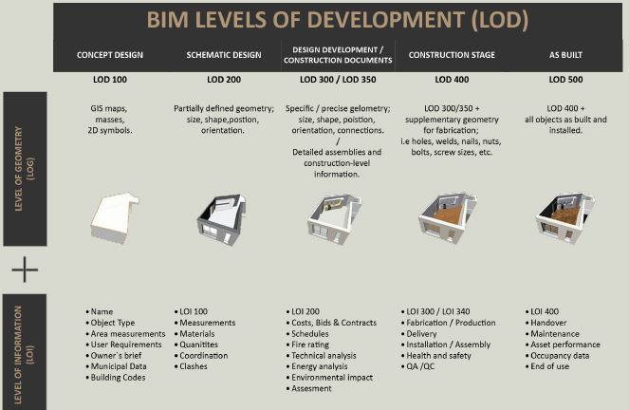
Reference diagram — BIM Levels of Development (LOD), as shown in the original questionnaire.
2.1a Required LOD / project stages / building elements:
Your answer: ___________________________________________________________
____________________________________________________________________
____________________________________________________________________

SECTION 02 / 06
Information Requirements
Continued — attributes, standards and As-Built handover.

2.2 What data attributes are essential for each element?
☐ Manufacturer
☐ Model number
☐ Warranty
☐ Energy consumption data
☐ Maintenance schedule
☐ Other: ___________________________________________________________
Your answer: ___________________________________________________________

2.3 Do you have existing data standards or naming conventions that need to be followed?
Your answer: ___________________________________________________________
____________________________________________________________________
____________________________________________________________________
____________________________________________________________________

2.4 What are your requirements for the “as-built” model at project handover?
Your answer: ___________________________________________________________
____________________________________________________________________
____________________________________________________________________
____________________________________________________________________

SECTION 03 / 06
Collaboration & Communication
The “How” — platforms, software, coordination and exchange.

3.1 What is your preferred method for information exchange and collaboration?
☐ Common Data Environment (CDE)
☐ Specific cloud platforms
☐ Traditional file sharing
☐ Other: ___________________________________________________________
Your answer: ___________________________________________________________

3.2 Do you have any existing software preferences or mandates for the project team?
Your answer: ___________________________________________________________

3.3 Who are the key stakeholders on your side (owner, facility managers, operations team) who need access to BIM information, and what level of access do they require?
Your answer: ___________________________________________________________

3.4 How often do you expect model updates and coordination meetings?
Your answer: ___________________________________________________________

3.5 What are the protocols for issue tracking and resolution?
Your answer: ___________________________________________________________

3.6 How will design changes be communicated and incorporated into the models?
Your answer: ___________________________________________________________

SECTION 04 / 06
Roles & Responsibilities
Identify BIM representatives, resources and decision-makers.

4.1 Who is the client's main point of contact for BIM-related matters?
Your answer: ___________________________________________________________
____________________________________________________________________

4.2 Do you have an internal BIM champion or representative?
Your answer: ___________________________________________________________
____________________________________________________________________

4.3 What internal resources do you have available to support BIM implementation (personnel, IT infrastructure)?
Your answer: ___________________________________________________________
____________________________________________________________________
____________________________________________________________________

4.4 What is your understanding of the roles and responsibilities of the various parties involved in a BIM project (e.g., Information Manager, BIM Coordinator, Lead Appointed Party)?
Your answer: ___________________________________________________________
____________________________________________________________________
____________________________________________________________________

SECTION 04 / 06
Roles & Responsibilities
Continued — approval workflows and accepted deliverables.

4.5 Who are the key decision-makers on your side who need to formally approve information delivered through BIM models? (e.g., Head of Design, Project Manager, Operations Manager, Facility Manager)
Your answer: ___________________________________________________________
____________________________________________________________________
____________________________________________________________________

4.6 What is the required approval workflow for different types of information or model deliverables at various project stages? (e.g., initial concept models, detailed design packages, construction coordination models, as-built documentation, facility management data).
Your answer: ___________________________________________________________
____________________________________________________________________
____________________________________________________________________

4.7 Do you have any existing internal systems or platforms you use for document control and approvals that should be integrated or considered?
Your answer: ___________________________________________________________
____________________________________________________________________
____________________________________________________________________

4.8 Who is responsible for issuing the final “Accepted” status for key model deliverables or data sets?
Your answer: ___________________________________________________________
____________________________________________________________________

SECTION 05 / 06
Contractual & Legal
Contract clauses, intellectual property and responsibilities.

5.1 Are there any specific contractual requirements or clauses related to BIM that need to be addressed?
Your answer: ___________________________________________________________
____________________________________________________________________
____________________________________________________________________
____________________________________________________________________

5.2 How will intellectual property rights for the BIM models be handled?
Your answer: ___________________________________________________________
____________________________________________________________________
____________________________________________________________________
____________________________________________________________________

5.3 What are the liabilities associated with the use and reliance on BIM data?
Your answer: ___________________________________________________________
____________________________________________________________________
____________________________________________________________________
____________________________________________________________________

SECTION 06 / 06
Training & Capabilities
BIM maturity and support needs across the client organization.

6.1 What is the current BIM maturity level of your organization?
Your answer: ___________________________________________________________
____________________________________________________________________
____________________________________________________________________
____________________________________________________________________
____________________________________________________________________

6.2 Do your internal teams require any specific BIM training to interact with the models or data?
Your answer: ___________________________________________________________
____________________________________________________________________
____________________________________________________________________
____________________________________________________________________
____________________________________________________________________

THANK YOU
Please return the completed questionnaire to info@novusba.eu.

